
PuzzPak

Run-through

Demo

- Main Menu
  - create new account “westfield”
  - Log into an existing account “wsu”.
  - wsu's profile in the Player Table:
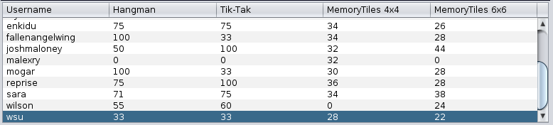
- Play Hangman
  - 3 difficulties with different words.
  - Score higher than 33% in Hangman with wsu in order to post.
- Play Tik-Tak
  - Game rules
  - Play 3 games, win at least 2 to get a score higher than 33 in order to post with wsu.
- Play MemoryTiles 4x4
  - Game rules
  - post with wsu
- Play Memory Tiles 6x6
  - Post with wsu

Error Testing & Constraints

- Log in with “WSU” all capitals. Forces lower case usernames.
- Try to create an account with 15+ characters: “dddddddddddddddd”
- Try to log in with null username.
- Try to post a score with a score less than 0.
Database Tables

Players Table
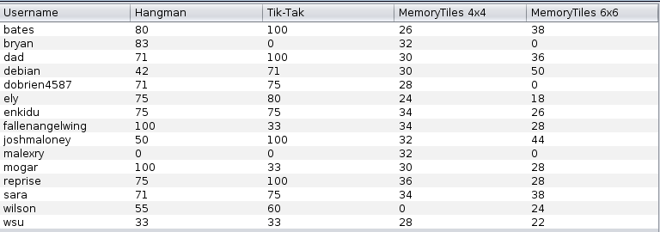
Hangman All-Time
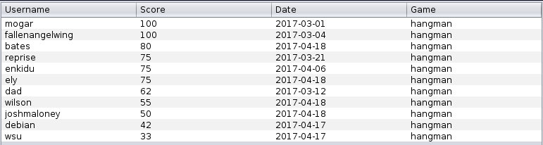
Tik-Tak All-Time

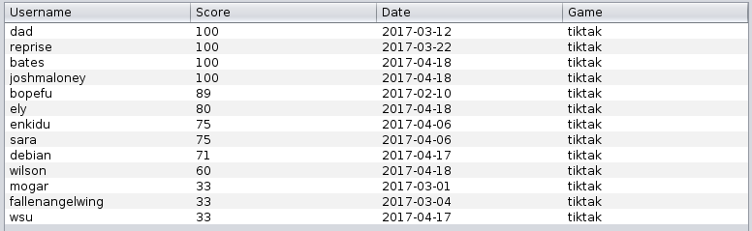

MemoryTiles 4x4 All-Time
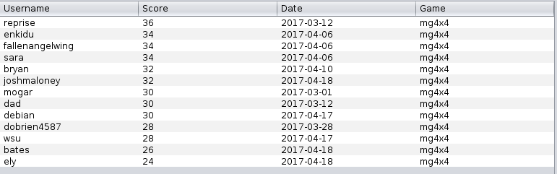
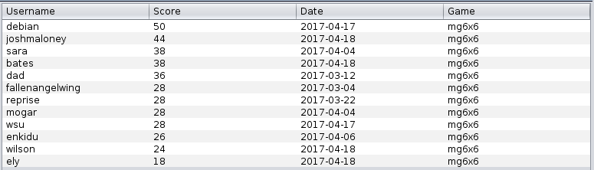
MemoryTiles 6x6 All-Time

- Homescreen
  - Homescreen is a launcher for everything: Games, leaderboard, settings, login.
  - Login Button
    - Must log in to post or participate in the leaderboard.
      - If you are new, a new account is created.
      - If you're returning, you simply log into your old account.
  - Hangman
    - How to play Hangman
    - show the differences with the difficulty.
    - How you win or lose
    - Posting rules.
      - Must play 3 games, and have win at least once.
  - Tik-Tak
    - How to play Tik-Tak
    - Winning combinations
    - Post Rules:
      - Must play 3 games (tie/win/loss), and have won at least once.
  - MemoryTiles
    - How to play the game.
    - How to win
    - Post rules:
  - Leaderboard
    - All-Time boards
      - Shows every score ever for that particular game in order from highest to lowest score.
      - Will only show 1 score (top score) per user.
    - Top-10 Board
      - Same data as the All-Time board but cuts off after the 10th entry.
    - Settings
      - Admin panel can remove/change/add users and their scores
      - Change database connection
      - View all all-time tables to see changes to DB.

